Instructions: Student Questionnaire Data Analysis Process

In Microsoft Forms open the student survey then go to the ‘Responses’ tab
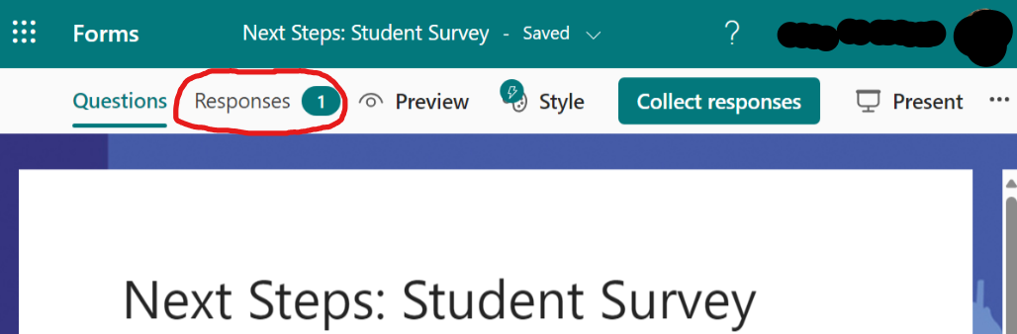
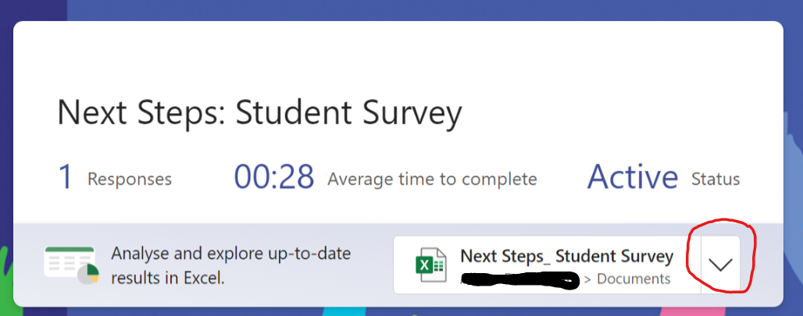
Click on the drop down arrow next to the Excel Icon saying ‘Next Steps_ Student Survey’

Select ‘Download a copy.’ This creates a file in your ‘Downloads’ folder called ‘Next Steps_ Student Survey.’
Go to Transform Data View, download and open the Excel Spreadsheet provided in the toolkit called ‘Student Survey Analysis’
In this excel spreadsheet, go to the ‘Responses’ sheet (bottom left tab)
Go to the ‘Data’ menu (top menu bar) and select ‘Get Data’ then ‘From File’ then ‘From Excel Workbook’
Browse to your ‘Downloads’ folder
Select the excel file ‘Next Steps_ Student Survey’ that you downloaded previously and click ‘Import’
A Navigator screen will open. Highlight ‘Sheet 1’
Click the drop down arrow next to the command ‘Load’ and select ‘Load to’
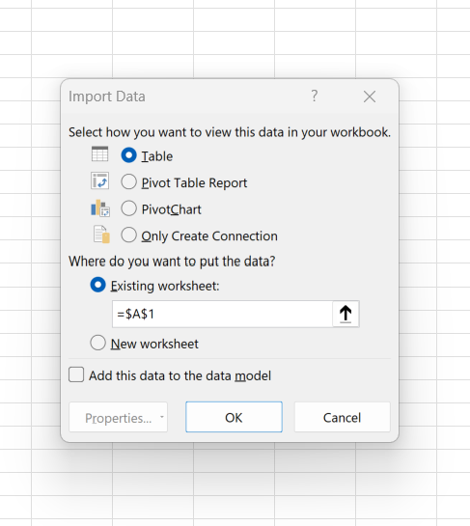
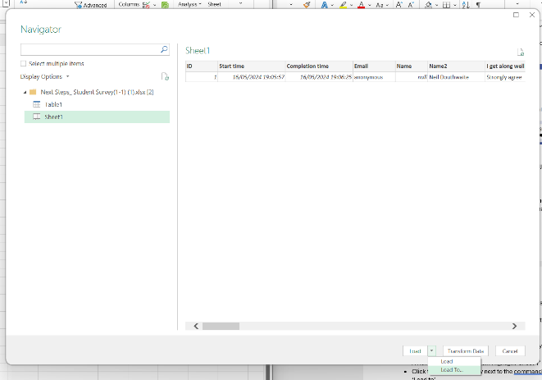
In the dialogue box that opens, check the button ‘Existing workbook’ and click ‘OK’

This will import all your students’ response data into the sheet named ‘Responses’ Go to the ‘Data Analysis’ sheet (bottom tab) to see your analysed data.

